“When we are unable to find tranquility within ourselves, it is useless to seek it elsewhere.”

VOLUME 11 ISSUE 10

In Good Hands

A Free Monthly Newsletter For The Friends and Patients of Ward Beecher DC

~ Francois de la Rochefoucauld



Looking for a safe and effective back pain treatment?

Breaking Back Pain News:

Survey Says Chiropractic Outperforms Other

Back Pain Treatments – Even Medication

Other topics covered in this newsletter:
- Neck pain and headaches: What you should know to start ending your pain and achieve lasting relief
- Why hand sanitizers put you at risk for viruses
- What 66% of mothers can do to strengthen their babies’ immune systems
- Tips to make going back to school healthier
The story we ALL need to learn right now: How 17 days buried alive can change your life and maybe even change the world…

Houston – SURVEY SAYS!!!! If you have back pain… you are probably old enough to remember Richard Dawson first yelling that phrase on the popular 70s and 80s game show, The Family Feud.
If not – it doesn’t matter – you just learned something interesting about American pop culture and game show history. ☺
So, What Does The
Survey Really Say?
According to an August 9, 2011 article on chiroeco.com, “In a new survey, chiropractic outperformed all other back pain treatments including prescription and over-the-counter medications, deep-tissue massage, yoga, and Pilates. According to the American Chiropractic Association (ACA), this news reinforces the use of conservative care options as a first line of defense against pain.
The survey, released by a leading consumer product rating and survey publisher in late July, found that 65 percent of those surveyed using chiropractic care for back pain said it helped a lot. Only 53 percent of respondents using prescription medications found them as helpful.
“Additionally, about half of those surveyed who are using deep-tissue massage, yoga or Pilates said those treatments helped a lot and only 28 percent of respondents using over-the-counter medications reported that they helped a lot.
“Current evidence-based guidelines support the use of conservative care such as chiropractic for conditions such as chronic lower back pain.”
One serious eye-opener was that only 28% of respondents said over-the-counter medications helped a lot.
It has been known for quite some time that common over-the-counter non-steroidal anti-inflammatory medications (NSAID) have serious side effects. One of these side effects is that an estimated 16,500 people die every year.
Natural, conservative options like Chiropractic, deep tissue massage, yoga, and Pilates are most likely better and safer choices when it comes to relieving back pain.
What About Neck Pain
And Headaches?
Neck pain is very common and it can make your life miserable. If you suffer from headaches… there is a very good chance you suffer from a common type of headache called “cervicogenic headache.” This type of headache is caused by a problem in your neck.
One way to tell you might suffer from cervicogenic headaches is to identify if any neck motions cause the headaches or increase their severity.
Also, take a good look at yourself in the mirror. Does your head tilt to one side? Is your head posture bad? In other words, does your head stick out in front of you instead of sitting back over your torso? You’ll probably need a trained eye (like your Chiropractor’s) to see that one.
What Helps This
Type Of Headache?
According to an “evidence report” published by Duke University researchers, “Cervical spinal manipulation was associated with improvement in headaches in two trials involving patients with neck pain and/or neck dysfunction and headache. Manipulation appeared to result in immediate improvement in headache severity when used to treat episodes of cervicogenic headaches when compared with an attention-placebo control. Furthermore, when compared to soft-tissue therapies (massage), a course of manipulation treatments resulted in sustained improvement in headache frequency and severity. However, among patients without a neck pain/dysfunction component to their headache syndrome – that is, patients with episodic or chronic tension-type headaches – the effectiveness of cervical spinal manipulation was less clear.”
What 66% Of Mothers Can Do
To Strengthen Their Baby’s Immune System
According to the Centers for Disease Control and Prevention, only 38 percent of Rhode Island mothers nurse their babies six months after birth. The national average is 44 percent.
State Health Director, Michael Fine, says the state hopes to raise the percentage of Rhode Island mothers nursing at six months to 60 percent by 2020.
Studies show breast-feeding improves child’s health and is a low-cost alternative to formula.
Many experts believe breast feeding is one of the most important things a mother can do to help her baby develop a strong, natural immune system.
Hand Sanitizers May
Put You At Risk For Viruses
According to Medical News Today, “New research has found that hand sanitizers are not as effective as soap and water in health care settings at preventing viral outbreaks. In fact, they may even be responsible for outbreaks of seriously contagious viruses. As a common alternative to using soap and water, hand sanitizers are often regarded as being the most efficient way to cleanse hands.”
In February, a survey was presented at an American College of Preventative Medicine meeting. “The survey focused on 161 long-term care facilities and found that the preferential use of hand sanitizers over hand soap was linked to a higher risk of outbreaks of the highly infectious norovirus, a virus responsible for the majority of acute gastroenteritis cases.
“The study found that norovirus outbreaks were far more rampant in facilities where staff favored hand sanitizer use. In facilities where norovirus outbreaks occurred, members of staff were six times more likely to use hand sanitizers than soap and water for cleansing their hands.”
The misuse and improper use of antibiotics is known to create super bugs that are immune to antibiotics.
It is unclear if hand sanitizers are doing the same damage.
Best bet: Wash your hands with soap and warm water.

And don’t forget, if you ever have any questions or concerns about your health talk to us. Contact us with your questions. We’re here to help and don’t enjoy anything more than participating in providing you natural pain relief.

Inspirational Story Of The Month –
(Names And Details Have Been Changed To Protect Privacy)

How 17 Days Buried Alive Can Change Your Life –
And Maybe Even Change The World…
This record-setting story has 33 heroes and a supporting cast of millions…

It’s been just over a year since the Chilean Mine tragedy.
Most have forgotten all about it and have gone on with their lives.
For the 33 people who were trapped in that mine for 33 brutal days... their lives will never be the same.
One of the most amazing things about this story is how the miners handled themselves throughout the ordeal.
Evidence points to the fact that instead of breaking down and fighting, the miners stuck together.
They formed a “community” and helped one another.
One account states the only thing the miners argued about was who was going to be taken out LAST when they were rescued.
Each volunteered to let everyone else go first.
One writer in the Digital Journey recently commented on this and contrasted the Chilean miners to the riots in Great Britain…
“Inspirational though their story is, it is a sad indictment of British society that at this time, people, especially the young, have been rioting on the streets and even killing people because they have – we are told – given up hope. These men never gave up hope; would any denizen of Tottenham, Hackney or Birmingham’s inner city willingly have changed places with one of them?”
Clearly “hope” is something no one should ever lose. No matter how bleak the situation or how dark the circumstances – things can always get better.
The darkest hours are just before the dawn; and, when things change, they often change quickly. Terrible times give way to joy… just about overnight.
Everyone has hard times. They are all different, but they are also relative. Your hard times can be as painful as someone trapped in a mine… if you allow it.
For example, let’s look at the miners and how their lives turned out a year later.
Some of the miners used their brief fame to launch businesses and speaking careers... and they are doing well.
Others are broke and are having serious mental problems.
An article in the Guardian.co.uk states, "They are taking uppers, downers, stabilizers, I think they are over prescribed … They don't understand why they are taking them but they are fed up with pills... It is not pills they need, but the tools to deal with fame and the tools to renovate themselves."
This is an extreme example. Things are not always as easy as, “making the decision to succeed.”
But, if those miners could ban together and help each other survive in the toughest of times, then so can everyone else. If some of those miners could come through that tragedy and use the experience as a positive way to give them a great new life – I’m sure most of the people reading this can take steps to have a better and healthier life too.
Most of the time, it is not the problems we face – or the solutions we come up with – it is the decisions we make about how we react to the outcomes.
Take immediate steps to improve your life and make the decision to enjoy the positive instead of searching for the negative.
We love helping our patients and their friends and relatives through their tough times and getting them feeling better! We are here to help you stay feeling better and looking younger! Don’t be a stranger. You really can afford Chiropractic care! Don’t wait until you can no longer move!
Did You Know?...
Nuts and seeds just might boost your brainpower and balance your moods. Everything from the most common nuts -- such as walnuts, hazelnuts, cashews and almonds -- to the more exotic seeds and nuts can clear up that "brain fog" and enable you to think clearer and be happier than you ever imagined.
Walnuts are "brain food.” Walnuts are made up of 15 to 20 percent protein and contain linoleic (omega-6 fatty acids) and alpha-linoleic acids (omega-3 fatty acids), vitamin E and vitamin B6, making them an excellent source of nourishment for your nervous system. A healthy nervous system means both clearer and happier thinking. Under-consumption of omega-3-rich foods may actually lead to depression. The same walnuts that you can find in the baking aisle of just about any grocery store may also boost your mood.
Walnuts aren't the only nut with mood-boosting omega-3s, either. Flax seeds are an excellent source for omega-3s, making them a viable source for those who don't like to eat fish, the most common source of omega-3s.
Cashews are high in magnesium, which can "open up" the blood vessels in your body, including those in your brain. When more oxygen-rich blood nourishes your brain, like any organ, it operates better. By providing your body with phenylalanine, adding almonds to your diet can do wonders for your mental and neurological health. Additionally, almonds are high in riboflavin, which may boost your memory. Peanuts and pecans provide another important nutrient for optimal brain function, choline. Choline aids in both memory and brain development. Seeds and nuts are essential to a healthy, well-functioning brain.
Tip Of The Month – Tips To Make Going Back To School Healthier…
By the time you read this, if you have children, they are already back in school. If they are, then you know what it’s like to try to pack a healthy and safe lunch every day. Not too long ago officials from the Oklahoma State Department of Health offered some great tips to help parents out:
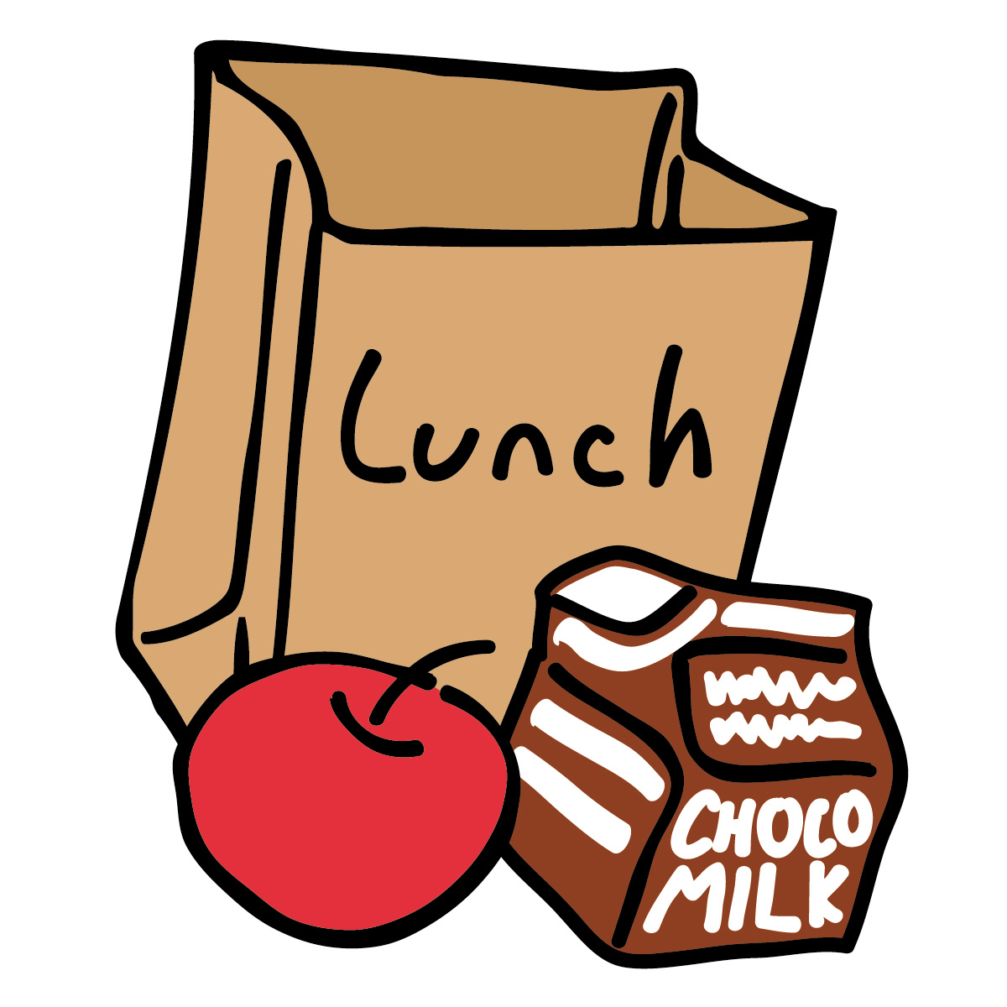
- Keep everything clean when packing the lunch. Use hot, soapy water to clean hands, clean preparation surfaces, and clean utensils. Wash your hands before you prepare or eat food. Wash insulated lunch bags with warm soapy water after each use.
- Use an insulated lunch box to help keep foods cold. Insulated, soft-sided lunch totes are best for keeping perishable foods chilled. You can also use a thermos to keep milk or juice cold until lunchtime. Perishable foods should not be out of refrigeration for more than two hours.
- Use freezer gel packs that are widely available in stores. If you cannot get freezer gel packs, freeze a juice box or plastic water bottle overnight and put that into the lunch box next to the sandwich.
- Keep your lunch in the coolest place possible! If there is a refrigerator at school, put your lunch in there. If not, keep it out of the sun and away from the heat.
- Pack shelf-stable foods, especially if you have a brown paper bag lunch. These food items include fresh fruits and vegetables, crackers, peanut butter sandwiches, canned meats, shelf-stable cheeses, packaged pudding, and canned fruits and juices.
- Rinse fresh fruits and vegetables under running tap water, including those with skins and rinds that are not eaten. Blot dry with a paper towel before packing them in your child's lunch.
- Use a thermos to keep soup, chili and stew hot. Use an insulated bottle stored in an insulated lunch box. Fill the bottle with boiling water, let stand for a few minutes, empty, and then put in the piping hot food. Keep the insulated bottle closed until lunch to keep the food hot.
- Make sure kids wash their hands before eating lunch. Encourage at least 20 seconds – about the time it takes to sing two choruses of the "Happy Birthday" song – of hand washing in warm soapy water.
- Discard perishable leftovers after lunch. Discard all used food packaging since bacteria can grow on plastic bags, aluminum foil, and paper. If you're packing your child's lunch with reusable bags, be sure to wash them daily with soap and hot water.
Remember, we’re always here to help your body heal
and maintain the health you deserve.

This information is solely advisory, and should not be substituted for medical or chiropractic advice. Any and all health care concerns, decisions, and actions must be done through the advice and counsel of a healthcare professional who is familiar with your updated medical history. We cannot be held responsible for actions you may take without a thorough exam or appropriate referral. If you have any further concerns or questions, please let us know by calling 281-286-1300.

