“The most beautiful thing we can experience is the mysterious. It is the source of all true art and science.” ~ Albert Einstein

VOLUME 12 ISSUE 7

In Good Hands

A Free Monthly Newsletter For The Friends and Patients of Ward Beecher DC

An Avocado A Day
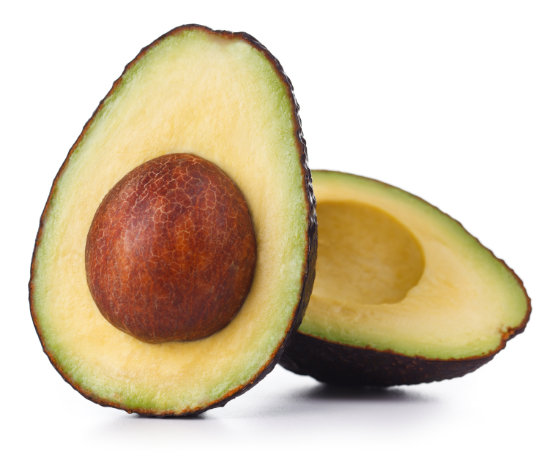
Can Help Keep
The Wrinkles Away?
More Great Stuff:
- Are Avocados An Anti-Aging Super Food?
- Want To Kill Weeds Without Toxic Chemicals?
- Did Chiropractic Care Help 15-1 Long Shot “I’ll Have Another” Win The Kentucky Derby?
- Former Professional Wrestler Helps Disabled Gulf War Veteran Lose 140 Lbs. And Walk Again!

H
ouston – “Just rub this wonder cream on and your face and all your wrinkles will instantly disappear!” We’ve all seen the commercials, and the results they show are pretty sensational. Isn’t it funny how that “wonder cream” is usually from some accidental discovery or from some magical plant in the rainforest?
What happens when you buy that wonder cream? Yeah, that’s right... NOTHING! Except your wallet is $19.95 lighter (plus shipping and handling).
So, instead of all that fantasy stuff, let’s talk about the real world and something you can eat that is good for you and might help slow the aging process.
That Food Is A Fruit &
It Is Called The Avocado
Why is the avocado so great? First, it has a very high level of oleic acid. Oleic acid is a monounsaturated fat that aids in fat metabolism.
Avocados also have high levels of lutein, zeaxanthin and Vitamin E. Lutein and zeaxanthin are carotenoid antioxidants. According to the American Optometric Association:
“Many studies have shown that lutein and zeaxanthin reduce the risk of chronic eye diseases, including age-related macular degeneration (AMD) and cataracts.
“Lutein and zeaxanthin are carotenoids that filter harmful high-energy blue wavelengths of light and act as antioxidants in the eye, helping protect and maintain healthy cells.”
Avocados also contain ionic potassium and folate. Potassium – Sodium ratios are very important to keep your heart healthy and functioning properly.
If you eat vegetables (and you should), here’s another great thing about avocados...
According to Natural News, most vegetables contain high amounts of carotenoid based antioxidants. “Studies have shown that these antioxidants are lipophilic (fat-loving) and are absorbed best in the body when combined with a healthy fat such as oleic acid.”
A study published in the Journal of Nutrition in March 2005 showed that adding avocados to salad increased absorption of alpha-carotene, beta-carotene and lutein 7.2, 15.3, and 5.1 times higher, respectively, than the average amount of these carotenoids absorbed when avocado-free salad was eaten.
In other words, eating avocados in your salad and with vegetables is (most likely) a very good thing!
What Type Of Avocados
Should You Eat?
Both Florida (the big avocados) and Hass avocados are good for your digestive tract because they contain soluble and insoluble fiber. However, Hass avocados have higher concentrations of lutein, zeaxanthin and some other nutrients.
Can Avocados Prevent Skin Wrinkling?
Some think avocados can prevent wrinkles and skin aging. It is believed avocados are great anti-aging foods because they contain D-manno-heptuloe sugar. This sugar has been shown to improve skin epidermis by boosting collagen formation.
Avocados contain antioxidants that may reduce age spots, decrease inflammation and help scars to heal.
Did Chiropractic Care
Help 15-1 Long Shot
“I’ll Have Another”
Win The Kentucky Derby?
Chiropractic care has helped countless people, including many world-class professional athletes and celebrities!
Chiropractors are musculoskeletal system experts, and since animals and horses have musculoskeletal systems, why wouldn’t Chiropractic care also help them?
Well, according to USA Today, Larry “Thumper” Jones has been helping horses with Chiropractic care for years.
Years ago, Jones suffered a hockey injury and had back surgery. His rehabilitation was unsuccessful, and it wasn’t until a Chiropractor treated him that he got better.
For 30 years now, Jones has been treating horses as an equine Chiropractor. He has worked with top racehorses such as $5.2 million dollar winning horse, Lava Man. He recently worked on I’ll Have Another the week before the 15-1 long shot won the Kentucky Derby.
According to USA Today: “Jones, 53, describes I'll Have Another as a ‘yoga specialist’ who has complete range of motion in his joints. He laughed, saying he wouldn't be surprised if the horse could put his leg behind his head. As a result, I'll Have Another should be able to take long strides, using less energy to get around the track.
“Keeping horses limber, relaxed and mobile is important, Jones said, as for any athlete. He said he uses instinct to know when a horse needs treatment, saying the animals often indicate the areas where they have tightness or pain.
“This week, I'll Have Another will get some massages, done with a vibrating machine that helps to loosen muscles and increase blood flow.”
It looks like Jones was right. I’ll Have Another did take some long strides and won the Kentucky Derby! (Editor’s note: After this article was written, I’ll Have Another also won the Preakness Stakes, the 2nd leg of horse racing’s Triple Crown, but had to pull out of the Belmont Stakes.)
If Chiropractic care is good enough for top professional athletes and Kentucky Derby winning horses, then it just might be good enough for you too!
And don’t forget, if you ever have any questions or concerns about your health, talk to us. Contact us with your questions. We’re here to help and don’t enjoy anything more than participating in providing you natural pain relief.

Inspirational Story Of The Month
(Names And Details Have Been Changed To Protect Privacy)

Former Professional Wrestler Helps Disabled Gulf War Veteran Lose 140 lbs. And Walk Again!

Arthur Boorman was a paratrooper in the Gulf War. All the jumps took their toll on his back and knees. Unable to easily move from the pain, he gained weight, ballooning up the 297 pounds. He was no longer able to walk without the assistance of two crutches.

Doctors told Arthur he would never walk unassisted again, and he believed them... for 15 long years. He was 47 years old and had given up hope.

He thought exercise was impossible. He wanted to try Yoga, but instructors wouldn’t give him a shot; that is, until he found an unlikely angel. As the story goes, one day Arthur stumbled across the website of former professional wrestler, Diamond Dallas Page (DDP). DDP’s yoga seemed different and inspirational to Arthur. So, he sent DDP an email detailing his situation. DDP read his story and looked at his pictures. His immediate reaction was, “God, how am I gonna help that guy?” But, he was willing to try. Arthur said, “He didn’t know me… but he believed in me… when no one else did.”

Arthur began trying DDP’s yoga via DVDs in his living room. He fell. Over and over again… he fell. But every time, he kept getting back up. He kept trying because someone believed in him. He also started eating the way DDP advised him to. He started losing weight and gaining balance. He fell less and less.

Then, the most important thing took place... Arthur started to believe it could happen. He lost 100 pounds in 6 months. Then, he lost 40 more. He sent DDP videos documenting every step of his amazing transformation. But, there was one video that made even this big, bad ex-pro wrestler cry.

In the last video, DDP could see Arthur walking unassisted for the first time in 15 years. No wheelchair. No crutches. Then, all of a sudden… Arthur started running! He picked up speed and sprinted by the camera. The end of the video says: “They were wrong… it was possible. Never underestimate what you can accomplish when you believe in yourself. Almost anything is possible when you believe in yourself. Never give up. I lost 140 lbs. in 10 months. Thanks DDP for believing in me.”

Notice he thanked DDP for believing in him and not the Yoga? It’s something to think about. Here’s the video: http://www.youtube.com/watch?v=bIXOo8D9Qsc

We love helping our patients and their friends and relatives through their tough times and getting them feeling better! We are here to help you stay feeling better and looking younger! Don’t be a stranger. You really can afford Chiropractic care! Don’t wait until you can no longer move!

Did You Know?...

- The average red blood cell lives for 120 days.
- There are 2.5 trillion (give or take) red blood cells in your body at any moment.
- A red blood cell can circumnavigate your body in less than 20 seconds.
- Nerve Impulses travel at over 25 mph (40 km/hr).
- A sneeze generates a wind of 100 mph (166 km/hr).
- A cough moves out at 60 mph (100 km/hr).
- Our heart beats around 100,000 times every day.
- Our eyes can distinguish up to one million color surfaces and take in more information than the largest telescope known to man.
- Our lungs inhale over two million liters of air every day.
- When we touch something, we send a message to our brain at 124 mph.
- We exercise at least 30 muscles when we smile.
- We make one liter of saliva a day.
- Our nose is our personal air conditioning system: it warms cold air, cools hot air and filters impurities.
- In one square inch of our hand, we have nine feet of blood vessels, 600 pain sensors, 9,000 nerve endings, 36 heat sensors and 75 pressure sensors.
- A person can expect to breathe in about 40 pounds of dust over his/her lifetime.

Tip Of The Month
How To Kill Weeds Without Toxic Chemicals!

If you have a garden or plant flowers, then you know how much of a pain weeds can be. They pop up everywhere and pulling them is not only time consuming but it can be brutal on your hands and back. Most of the time, weed picking involves a slumped over (bad) posture. Spend an hour or an afternoon picking weeds and you might feel some serious back pain!
But, the alternative, spraying toxic weed killing chemicals, has a serious down side. These chemicals are not a joke. Not only are they toxic to weeds, they are bad news for humans and pets, too. Getting them on your skin and inhaling them can be bad for your health. Then, there are the environmental issues of putting those chemicals into the ground. Rainwater washes them everywhere… into gardens, the food supply, the water supply, etc.
There is another way! Most people do not know the power of vinegar to kill weeds! Vinegar will even do it without all the potential hazards of the powerful chemicals. All you have to do is spray the vinegar on the leaves of the weeds until they are wet. In a few days, the weeds will be dead!
There are two things you should know about using vinegar to kill weeds: 1) Vinegar is activated by sunlight. So, check your weather report and try to pick a day when it will be sunny and not raining. 2) Vinegar does not discriminate! It will kill ALL plants that it is sprayed on. So, only spray it on the weeds you want to kill. Do not get it on your flowers, tomato plants, etc.
Besides being safe and effective, vinegar is pretty cheap. All types of vinegar will work and white vinegar is usually the cheapest. If you spray it on and it rains and the weeds do not die, it is easy and inexpensive to simply do it again. FYI: Vinegar is great to use to kill the weeds that grow in sidewalk cracks!

Remember, we’re always here to help your body heal
and maintain the pain free body you deserve.

This information is solely advisory, and should not be substituted for medical or chiropractic advice. Any and all health care concerns, decisions, and actions must be done through the advice and counsel of a healthcare professional who is familiar with your updated medical history. We cannot be held responsible for actions you may take without a thorough exam or appropriate referral. If you have any further concerns or questions, please let us know.

